See Jane Drill Tutorials:

* A Quick Guide to Nails:
  + How long a nail do I need? Is longer always better? 🡪 Not necessarily!
  + Jane’s rule of thumb:
    - **Your nail should be 3x in length the thickness of the stock you are nailing**
      * E.g. if ¾” lumber, then you should get a 2.25” nail!
  + What is up with “d”?
    - E.g. check out 6d, 8d, etc. on these boxes:
    - 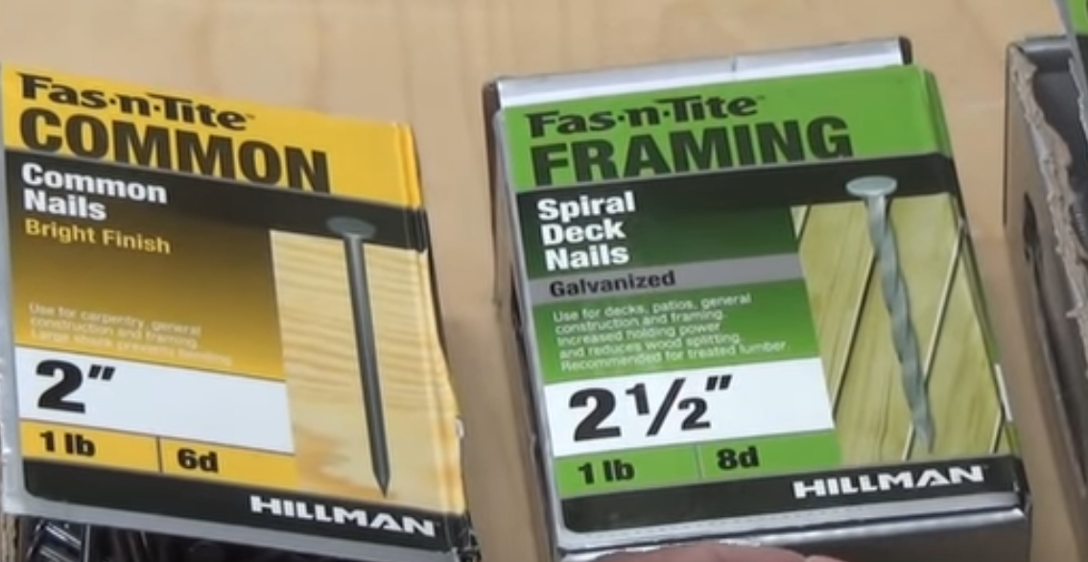
    - Don’t worry about it. The “d” notation is simply shorthand for carpenters, but it translates directly to the length of the nail. For your purposes, just worry about the actual length in inches, etc. that is given.
  + A quick look at *common nails:* 
    - These are used for **framing**
    - 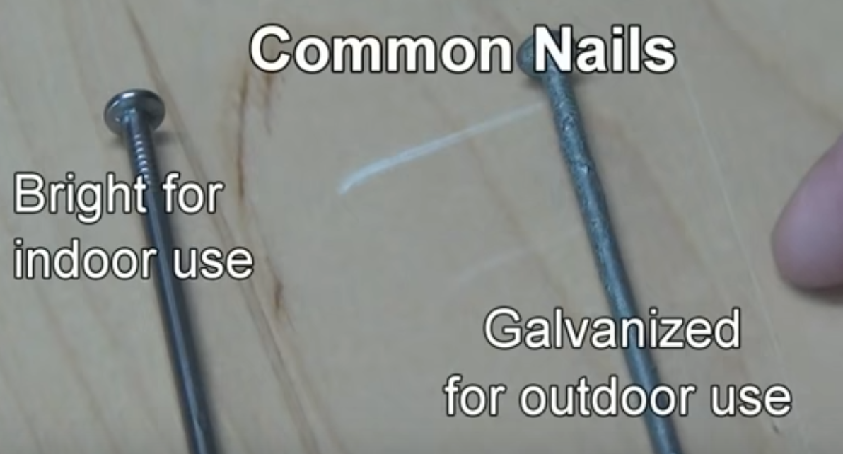
  + Duplex nails:
    - **Temporary** nails. They can easily be removed
    - 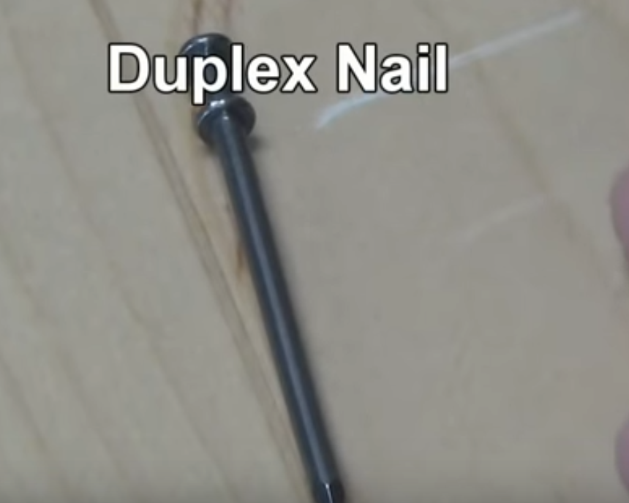
  + “Sinkers:”
    - Used for general construction. Has a vinyl finish that increases friction for optimal grabbing.
    - The *yellow color* and *waffle pattern on the head* distinguish a sinker nail
    - 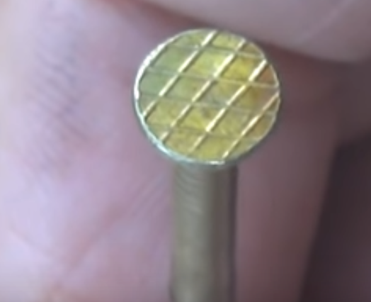
    - 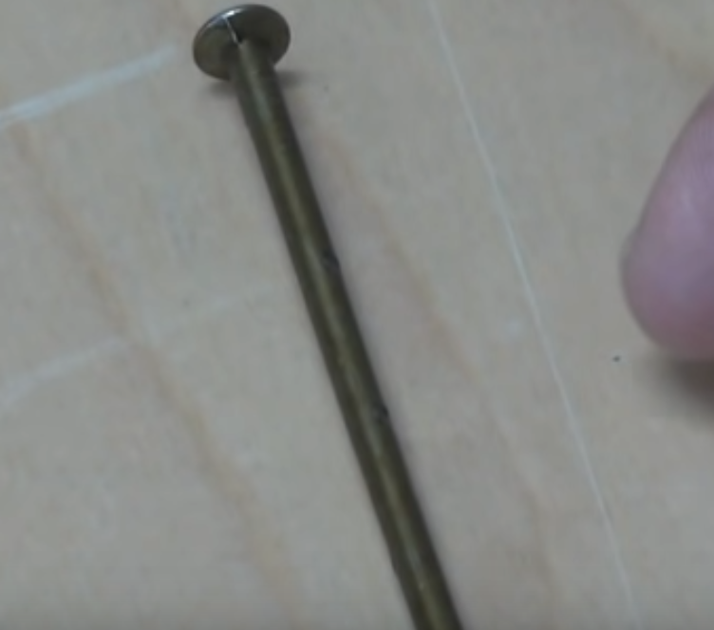
  + Masonry nail:
    - For driving into bricks,concrete, etc.
    - These are *reinforced with* ***hardened steel***
    - 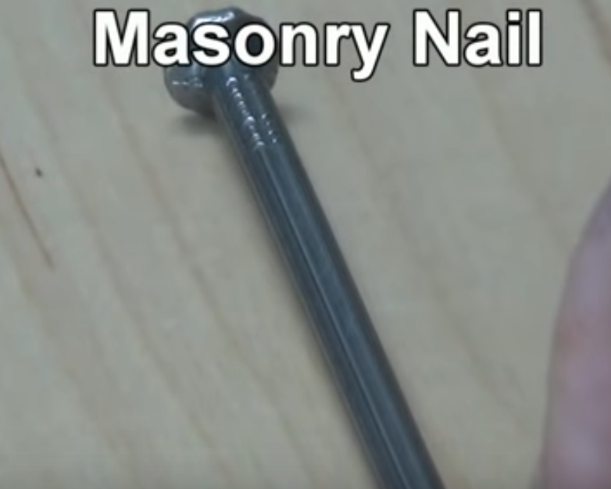
  + Spiral deck nail:
    - For decks. Great holding power across many different temperature swings when wood may expand/shrink.
    - 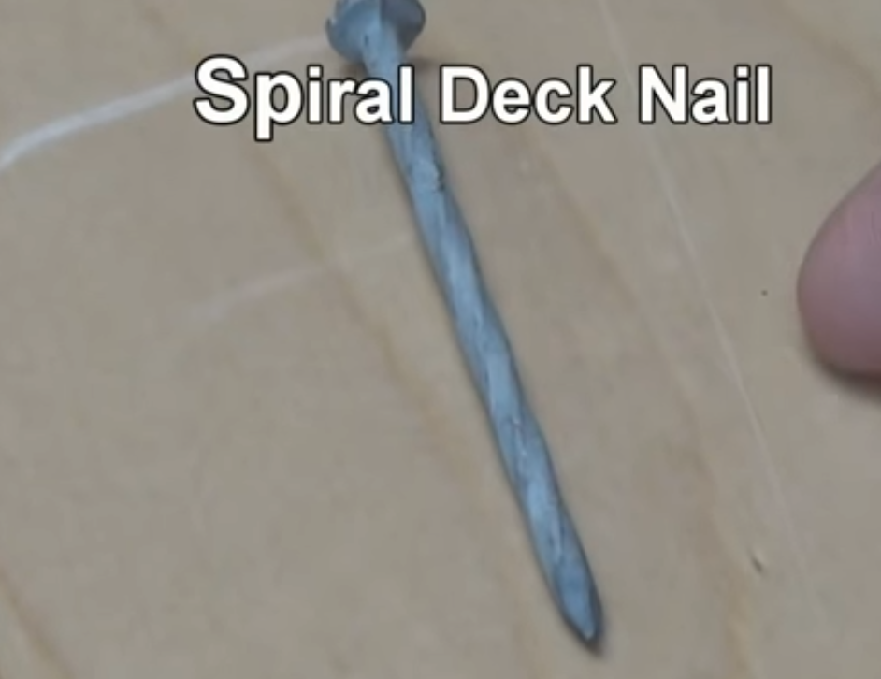
  + Ringshank Nail:
    - Like the spiral, helps its holding power. But, unlike spiral nail above, it is **only meant for interior use.**
    - 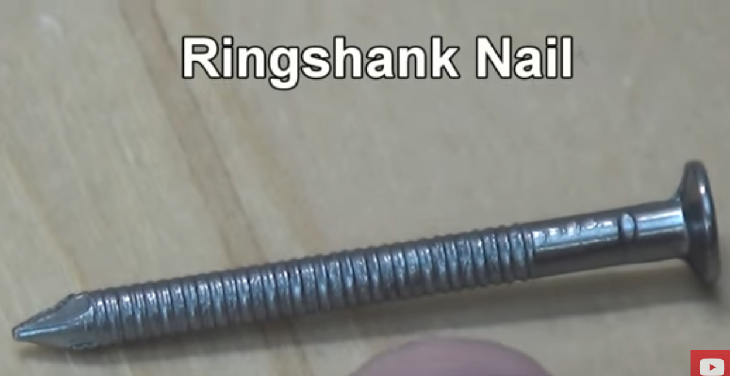
  + Finishing nails:
    - For door/window frames.
    - You should drive the nail **to completion** with something called a “nail set”
    - 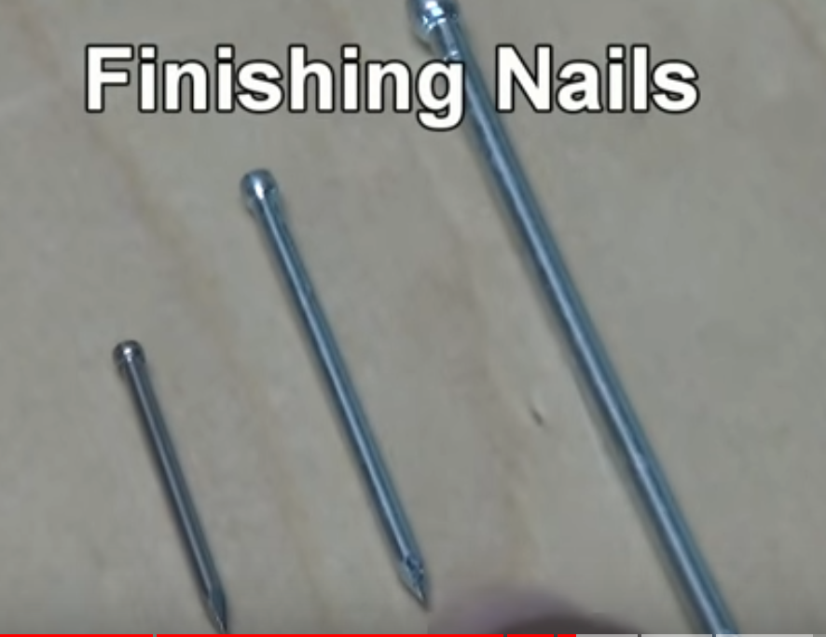
  + “Low velocity powder fastener” (drive pin)
    - For driving a nail through **steel** or **concrete**
    - You do not use a hammer; you instead use a “red head” or a “powder actuated tool”
    - 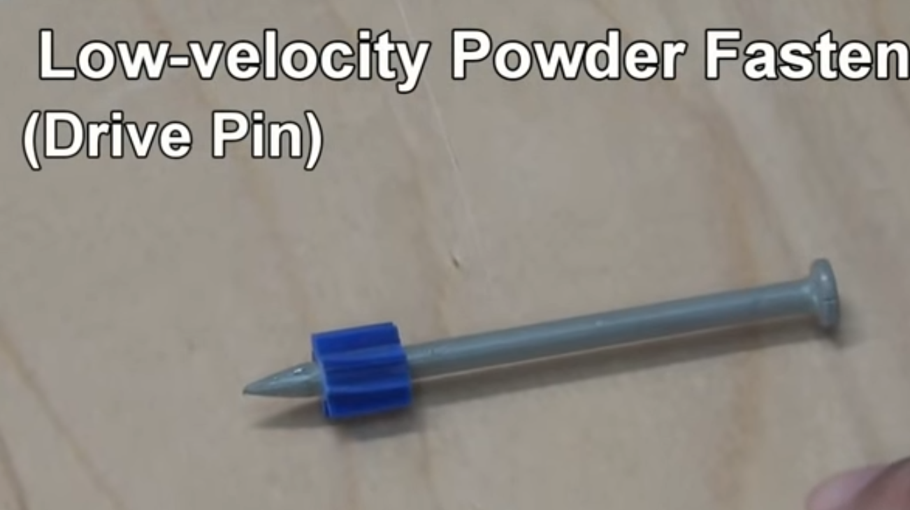
    - Powder actuated tool:”
    - 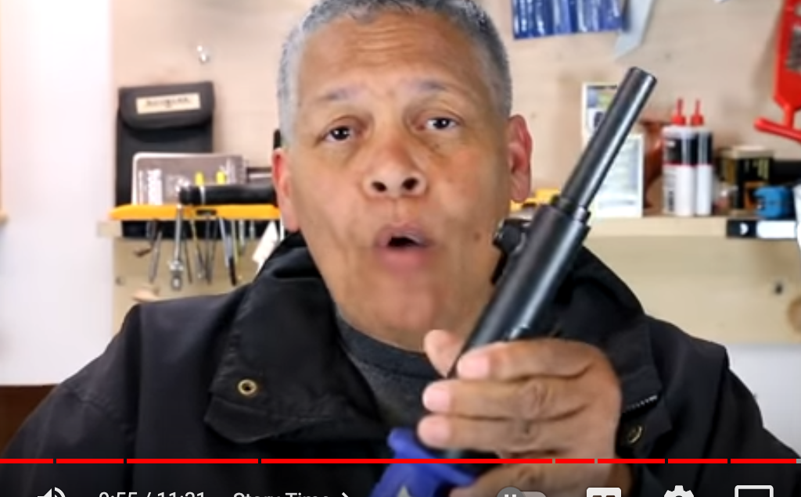
    - “Red head”:
* 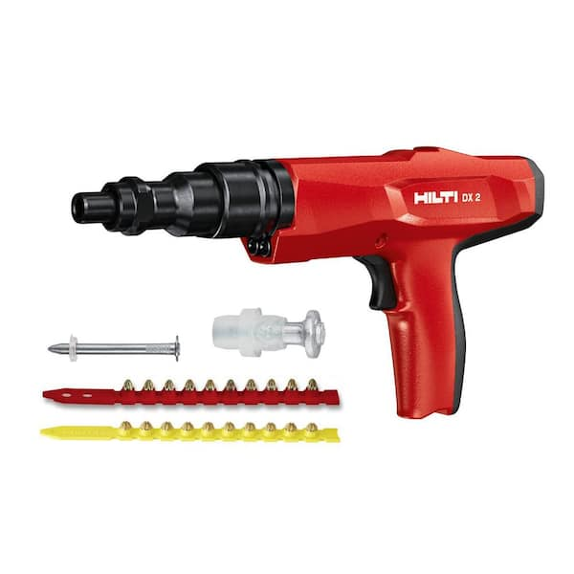
* How to drive/pull a bent nail:
  + Drive it **from the side of the bend:**
  + 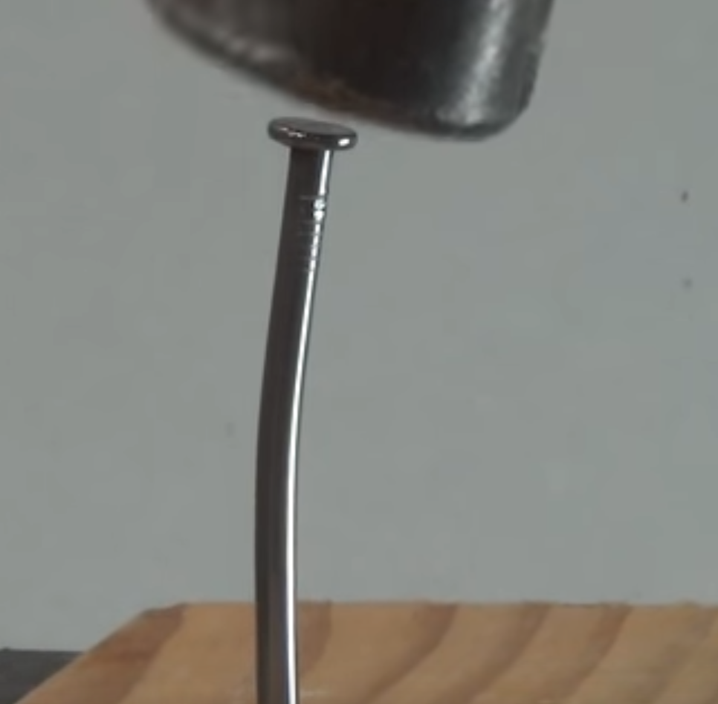
  + **Pull it** by placing a 2x4 or something (e.g. another hammer, screwdriver, etc) at the shaft so that you bring the fulcrum closer to the lever’s action:
    - 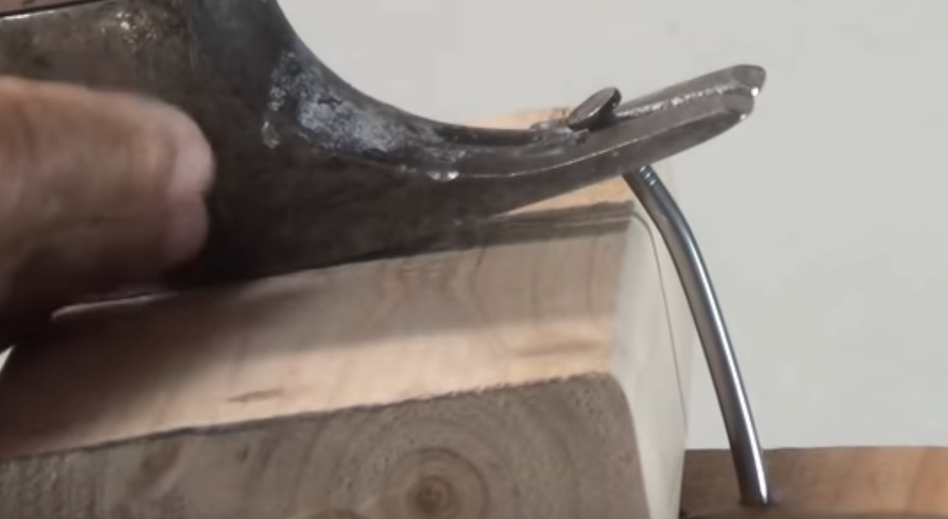
  + You can also pull the nail by hammering it all the way down and then using the bend in the shaft to secure the hammer, as you pull close to the where it’s entering into the wood:
  + 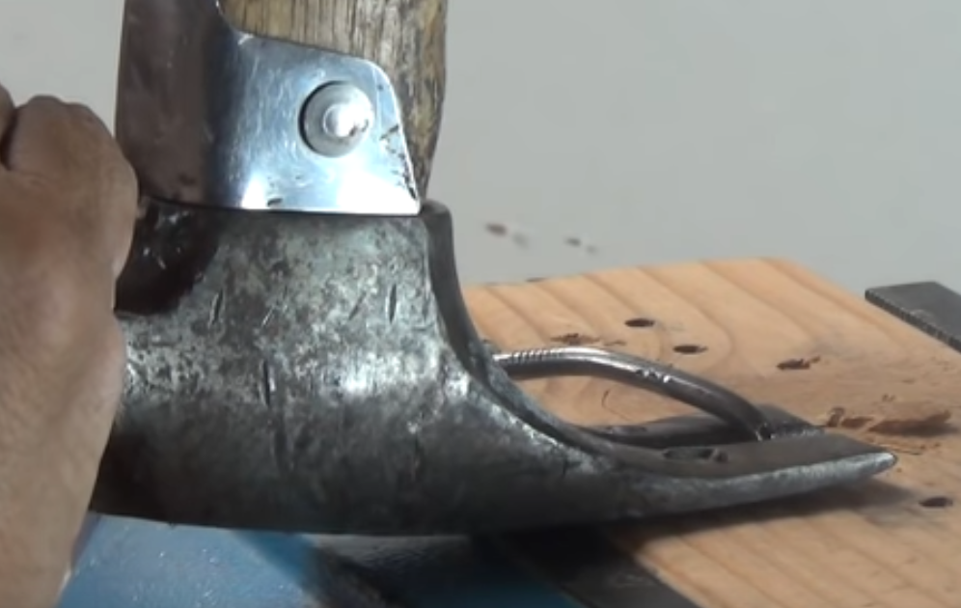
* **Add pop to a dull wall with a chair rail:**
  + A great way to add “pop” to an empty wall is with molding. But what if that’s too fancy for your taste? Well…that’s where a **chair rail comes in!**
  + Tutorial:
    - 1. Leah recommends going ~32” off the floor. Mark it w/ a laser level:
    - 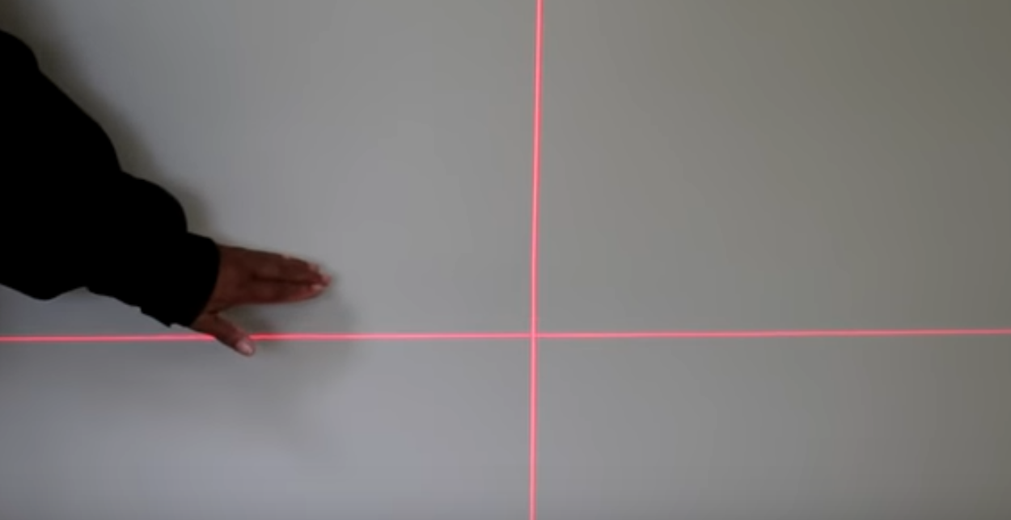
    - 2. Next, mark stud locations along laser line:
    - 3. Nail in the piece (Leah recommends *hemlock*)
      * If you’ve got a compressed air nail gun, then go with that
      * Else: Use a hammer/nail set with finishing nails
    - 4. Fill in the pockmarks with wood filler, then paint as you see fit : )
  + What if you have a **long wall** and need 2 pieces of chair rail?
    - Go for a “**scarf joint”** (cut at ~45 degree angle)
    - 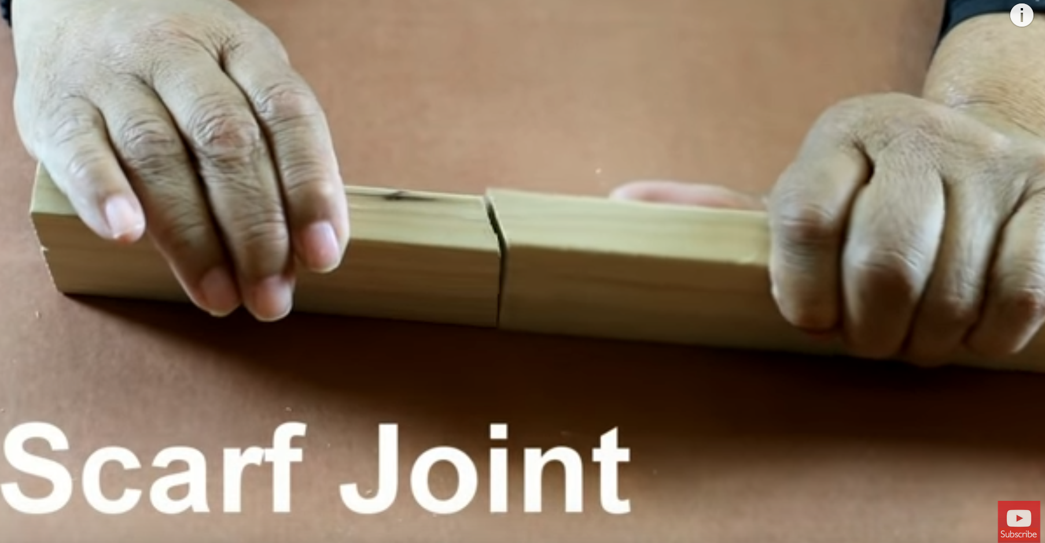
    - Better than a *butt joint*, because more resistant to wood expansion/contraction and it is a more elegant way to disguise a joint
* “A Surprisingly Easy Woodworking Joint for Beginners” (**Rabbet joint)**
  + You know what a rabbet cut looks like.
    - Did you know it’s called a “rebate” in the UK?
  + There are many ways to cut a rabbet (table saw, router, etc.) but this video demonstrates with a **router**
  + Tutorial (with a **table saw**):
    - 1. Use a **combination square** to measure out the thickness of what you’re going to be cutting (e.g. by calibrating it to the “setting piece” that will settle into the rabbet).
    - 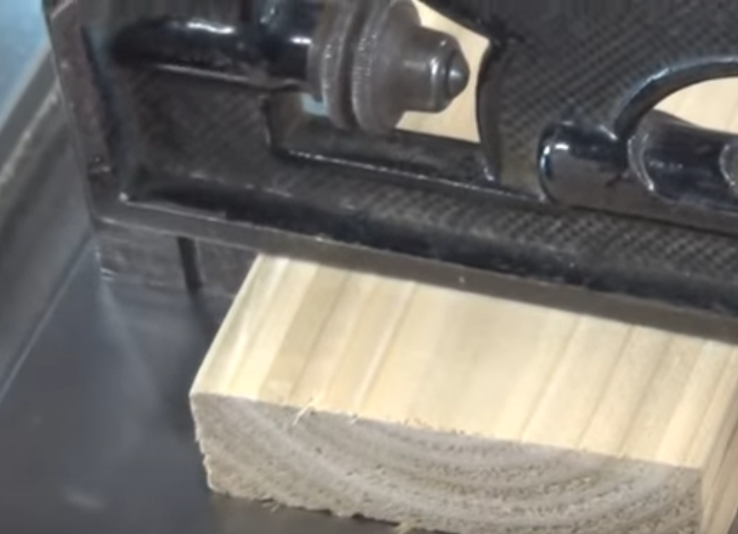
    - 2. Set the height of the blade. You you can use setup bars, or **simply set the height of the blade itself by eyeballing it** 
      * 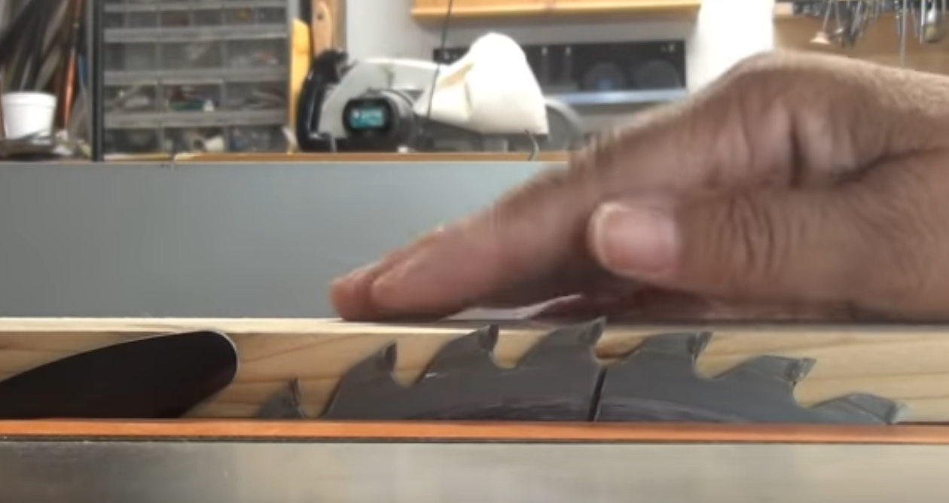
    - 3. Set the **width** at which to place the fence.
      * With a combination square, it looks like this (with your thickness already measured out…note that the tool is **right up against the blade**):
      * 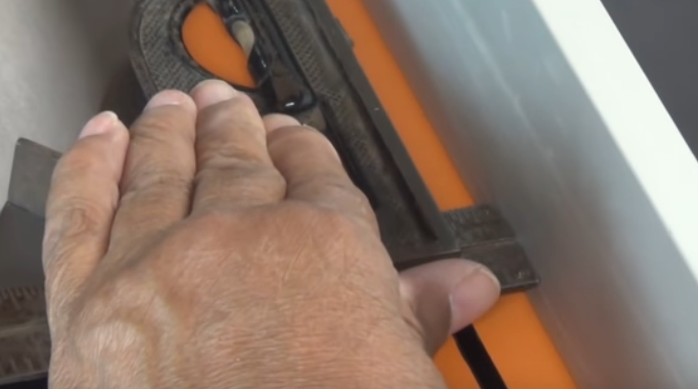
        + If using a setup bar, note that you have to account for the kerf of the blade:
        + 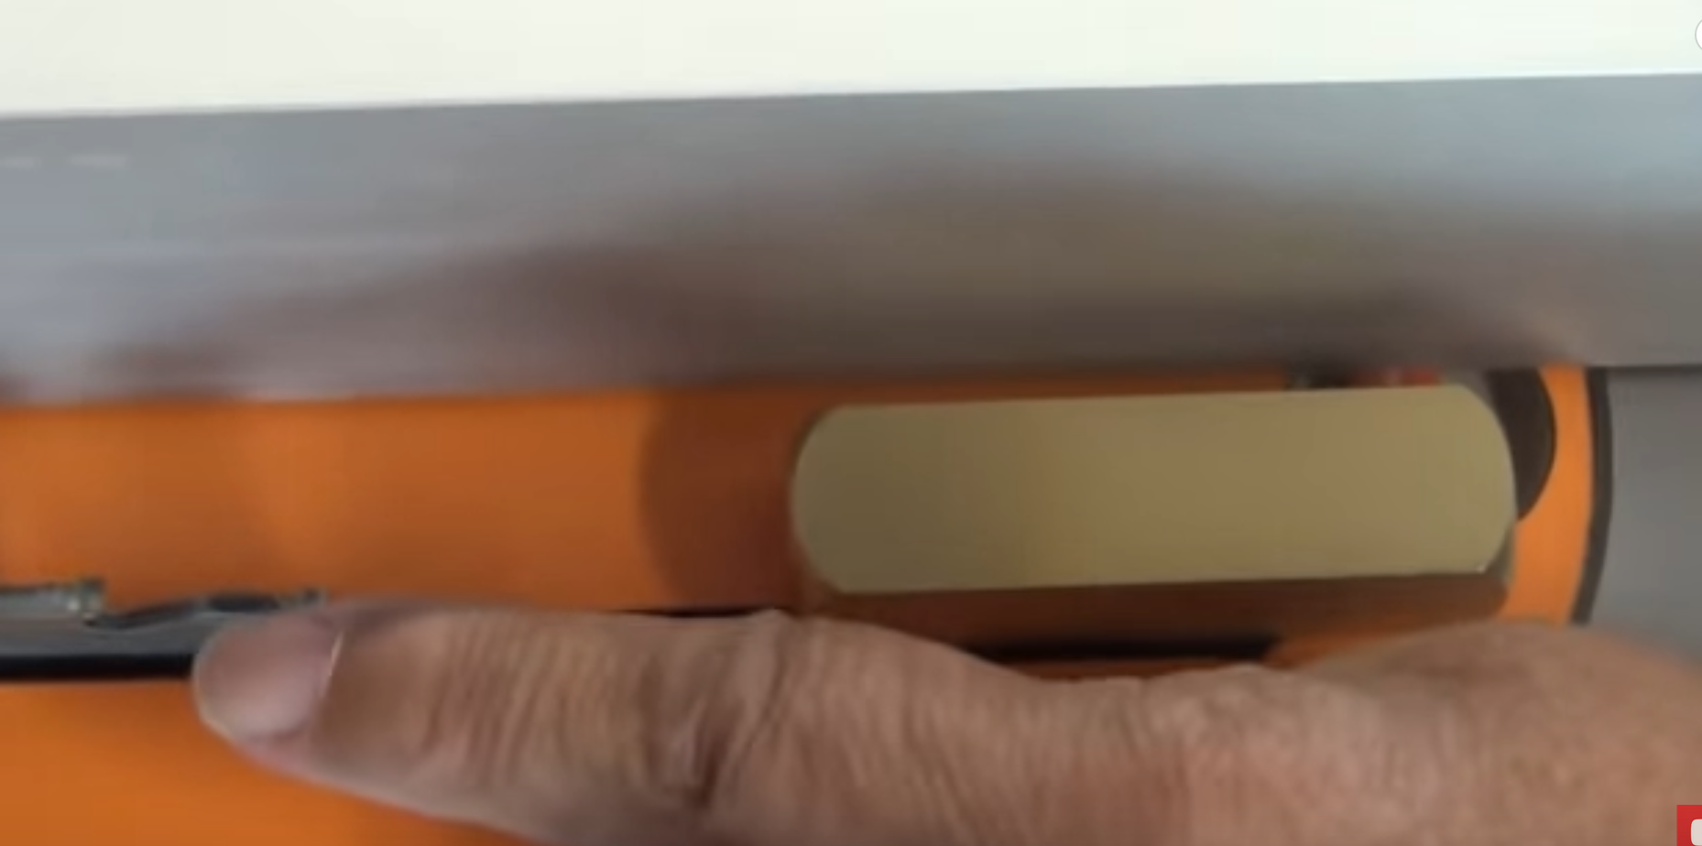
    - 4. Do your first cut:
      * 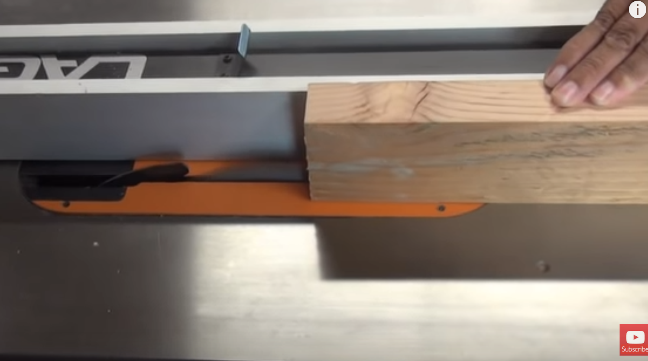
      * 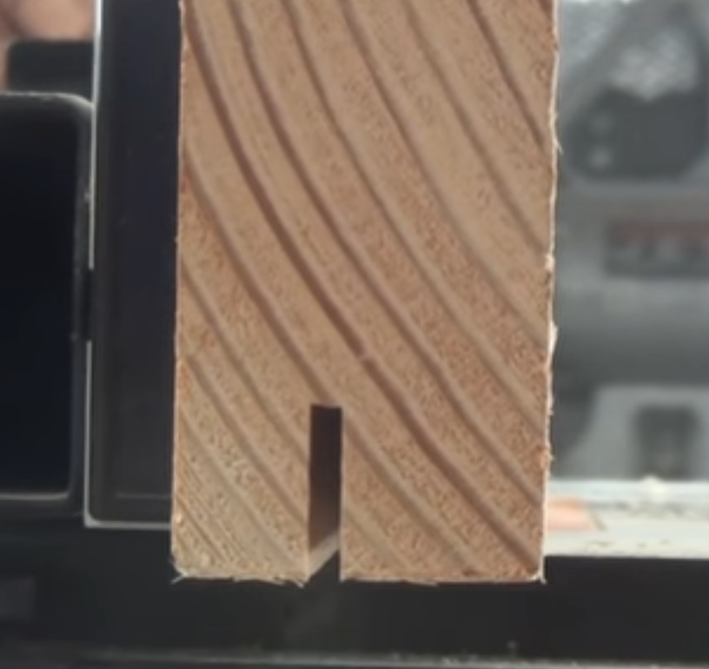
    - 5. Rotate 90, then perform second cut
      * 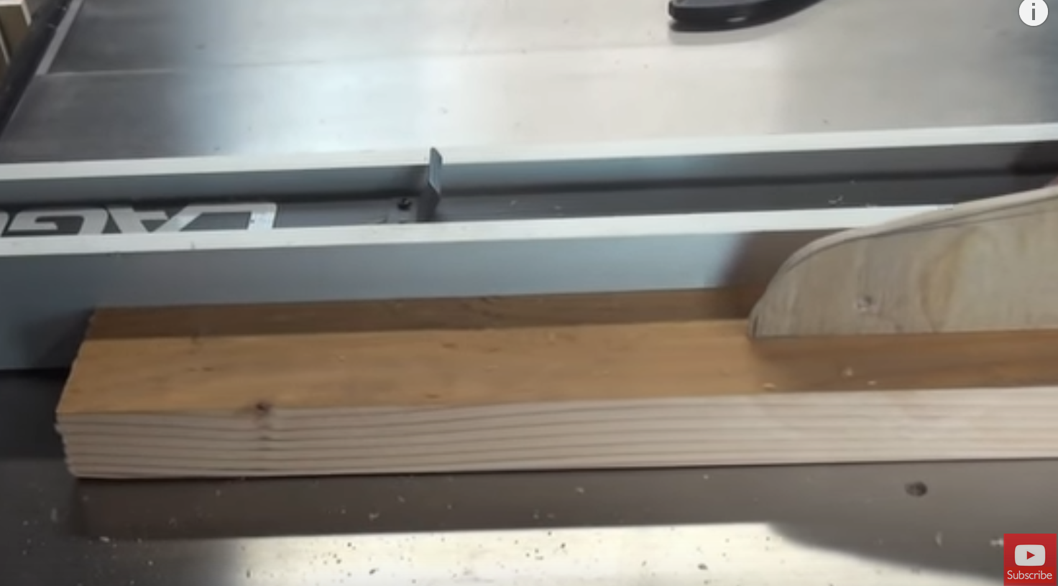
    - That’s it!
* Spline Miter Joint (“A beautiful easy woodworking joint for beginners”)
  + Overall idea:
  + 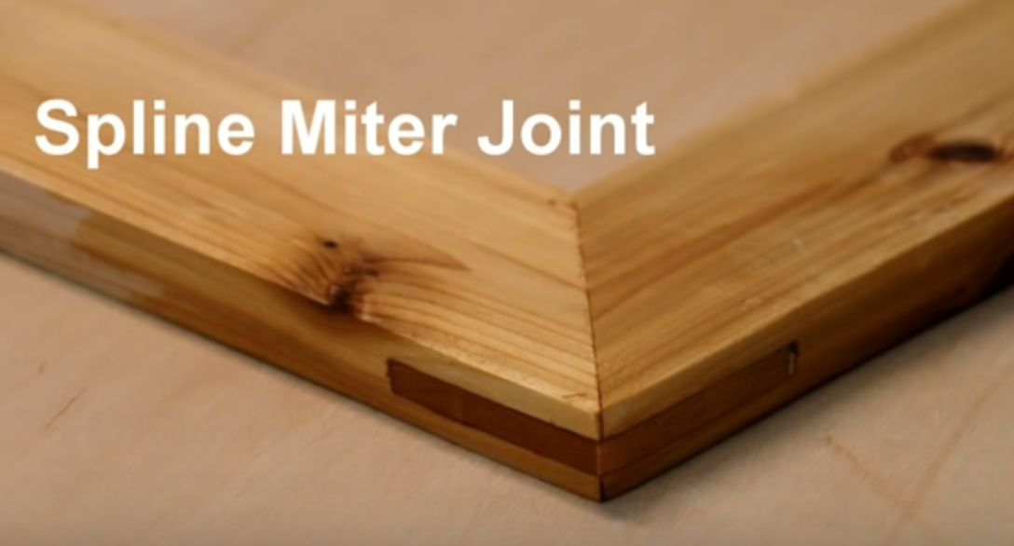
  + You’ve got two 45 degree miter cuts for a **miter joint** and the place a spline into it to strengthen/stylize the overall joint
    - Note that miter joints are actually **very weak** by themselves because end grain soaks up glue like a sponge!
    - Putting a bunch of “long grain” surface area strengthens the joint
  + To make things easy for yourself, you should make a **spline jig**:
    - 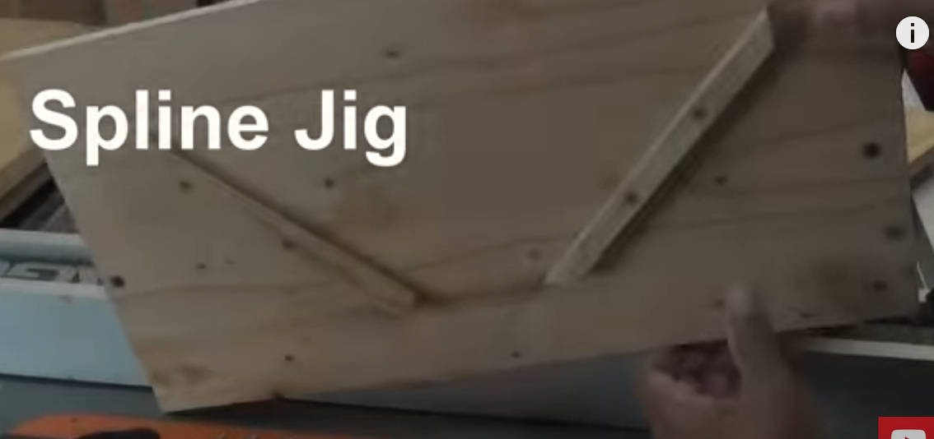
    - 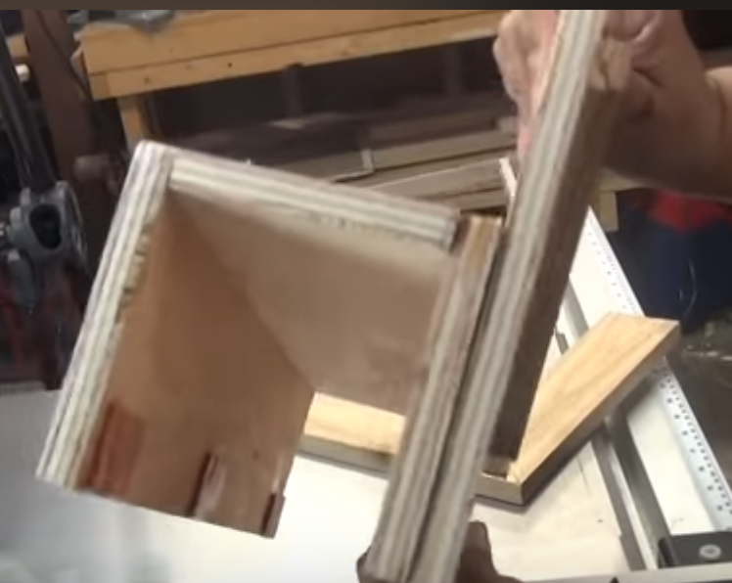
    - It should rest on top of your fence just like a sleeve:
      * 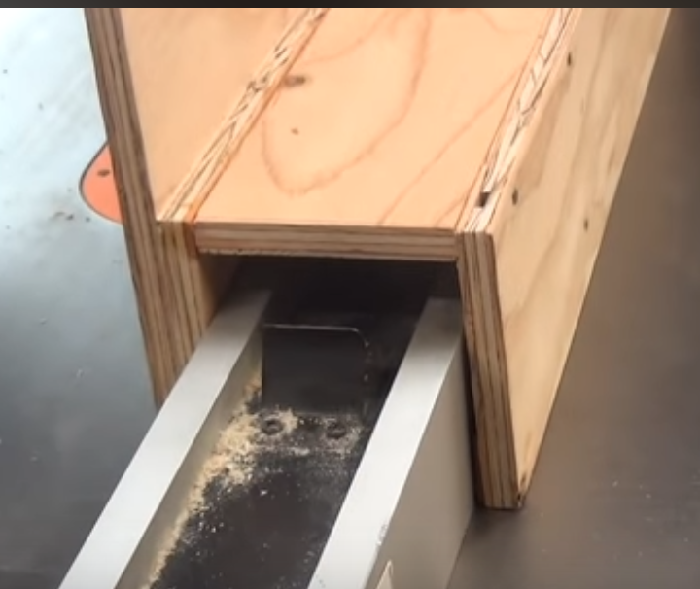
    - This is how you use the spline jig:
    - 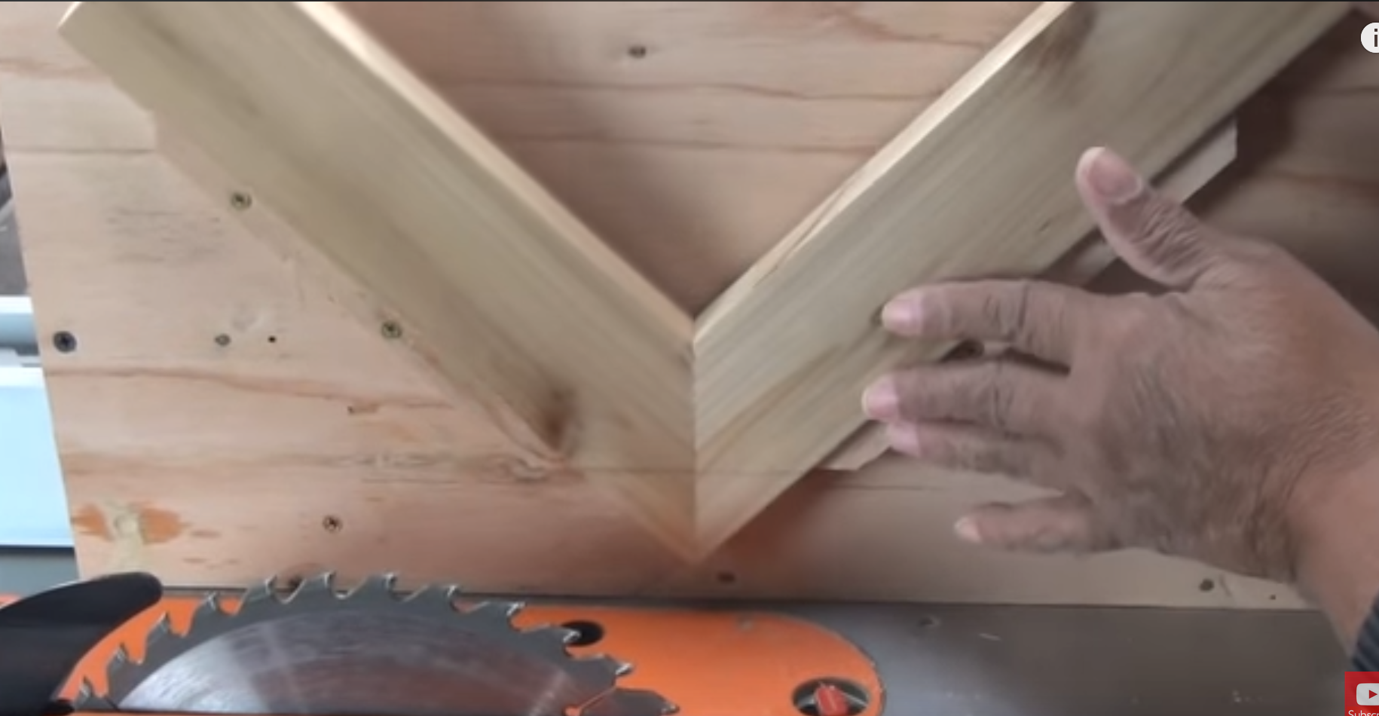
  + Tutorial:
    - 1. Put together your miter joint
    - 2. Use spline jig as above to cut a groove. Glue in a properly-sized piece of spline!
    - 3. Sand down the joint where spline stands proud relative to surrounding joint.
    - 4. Throw a little mineral oil on in order to bring out the color of the spline (it should be a contrasting color to the frame)
  + Bonus Tutorial: How to Make a Spline Jig:
    - 1. Attach “face plate” to “sleeve,” each constructed from scrapwood:
      * 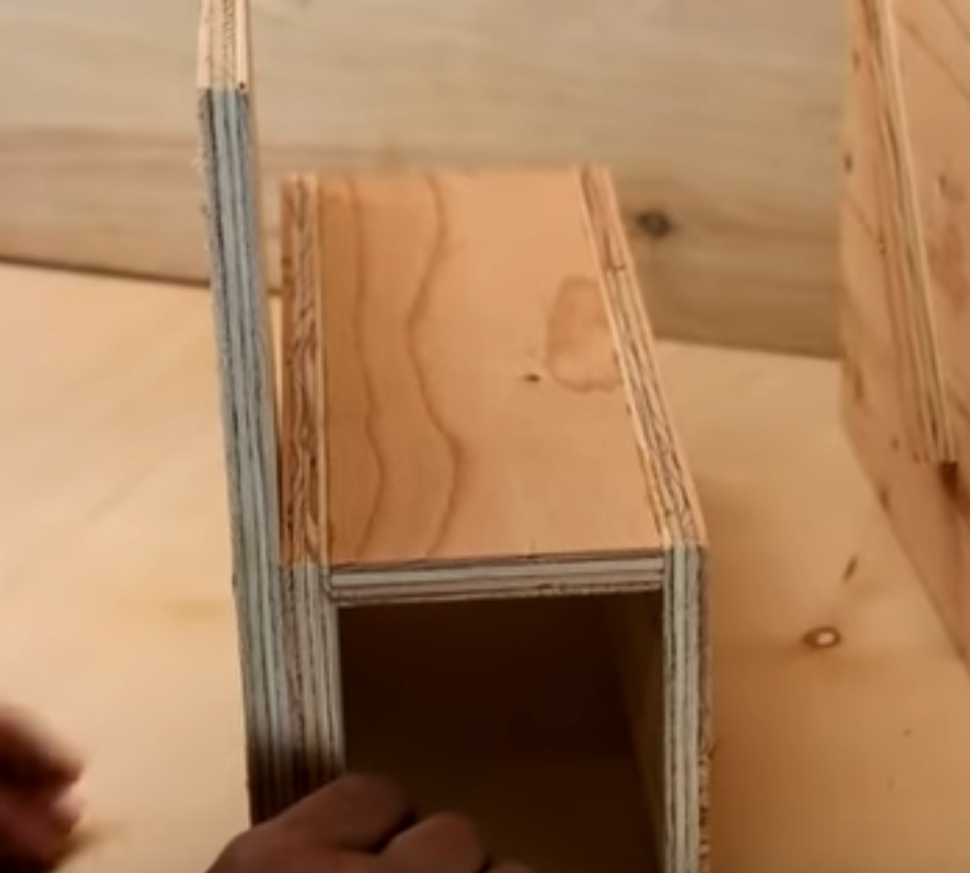
    - 2. Use a speed square or framing square to place the “guides” at appropriate 45 degree angles:
      * 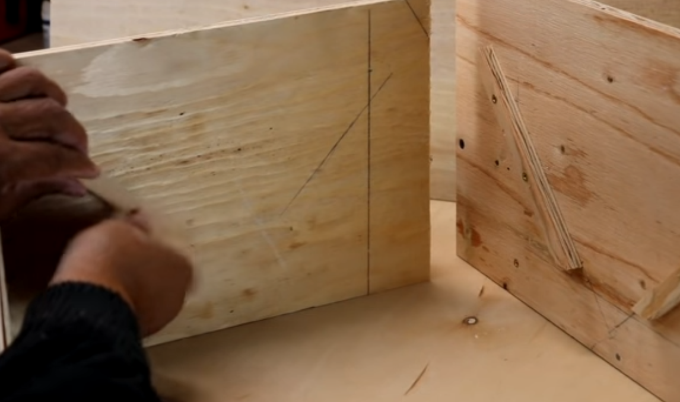
      * 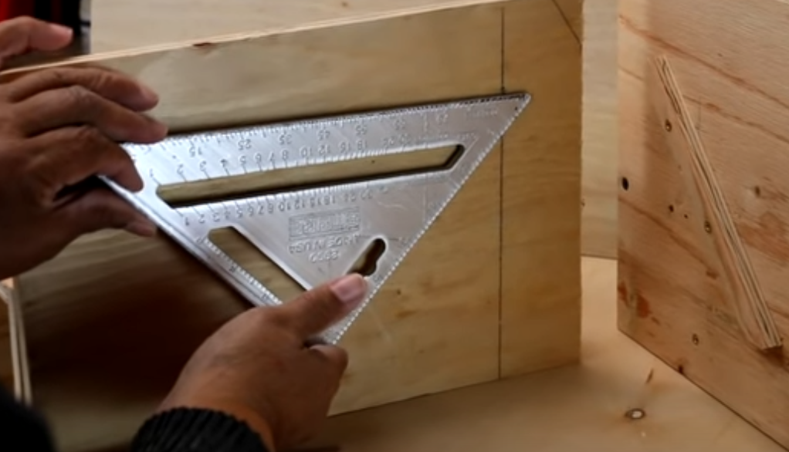
* A DIYer’s Guide to Drill Bits:
  + Titanium coated bits:
    - 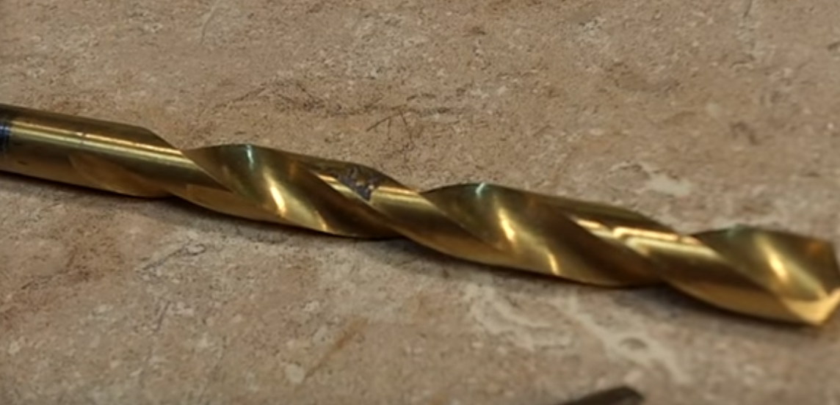
    - Why coated w/ titanium?
      * It produces less friction
      * Stays sharp longer
    - Why use a titanium bit?
      * Good on **wood, metal, PVC, and fiberglass!**
  + Brad-tip bits (Black oxide-coated)
    - 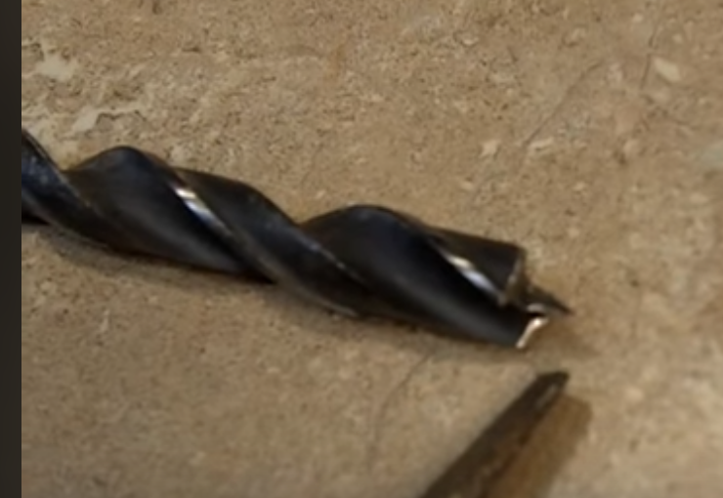
    - Note the sharp point at the end. That’s what makes it a “Brad tip.”
    - It’s particularly good for **wood**, as it makes a pilot hole as you go.
    - Note the black oxide coating above, which resists corrosion.
  + “Common bits”:
    - 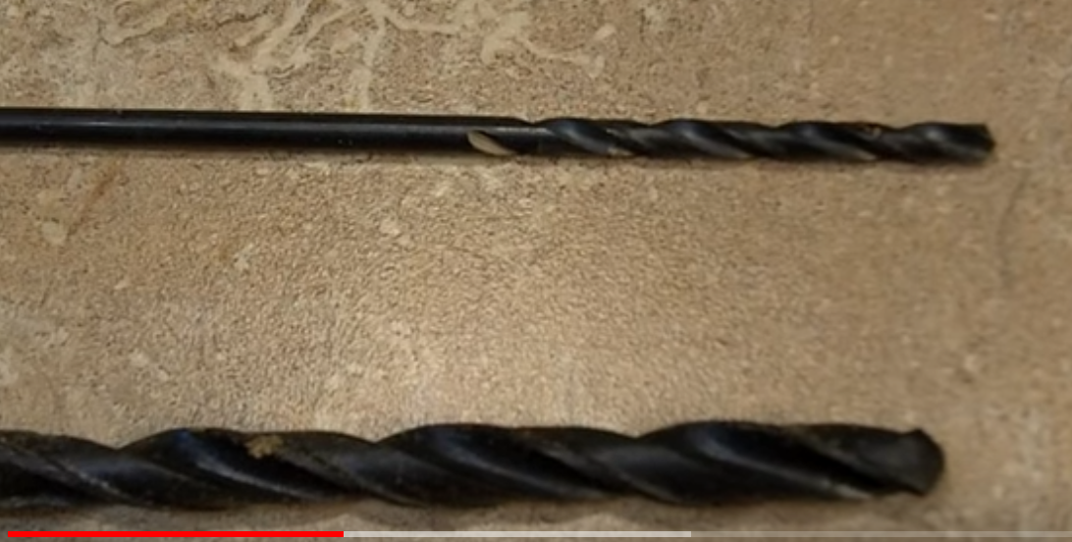
    - Just overall, decent “all-purpose” bits .
  + Hole cutting bits (spade, Forstner, hole saw, step-off bit)
    - Spade bits:
      * Mostly for **drilling large holes** in construction projects. (Not really for fine woodworking). You’ll get tear-out.
      * 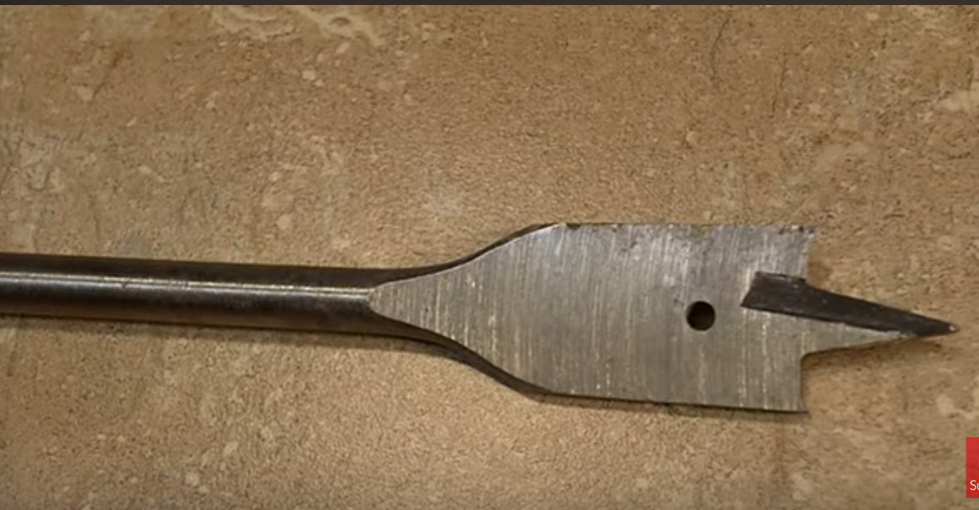
    - Forstner bits:
      * Just like spade bit, this is also for boring large holes. But it is better for fine woodworking, as there’s less tear-out.
      * 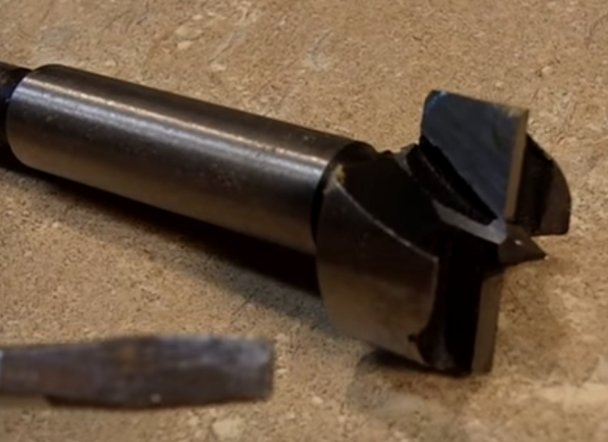
    - Hole saws:
      * Best used for installing hardware (e.g. doorknobs), making a passage for wiring, etc.
      * Not including a pic of it b/c you already know what it looks like/I’m too lazy
    - Step-off bit:
      * Not often used, but it’s mostly for **thin** materials (e.g. thin metal, thin plastic)
        + Note the variety of step-off diameters allows you to essentially “choose” which diameter hole you’d like to make
      * Note that this one here is also coated in titanium : )
      * 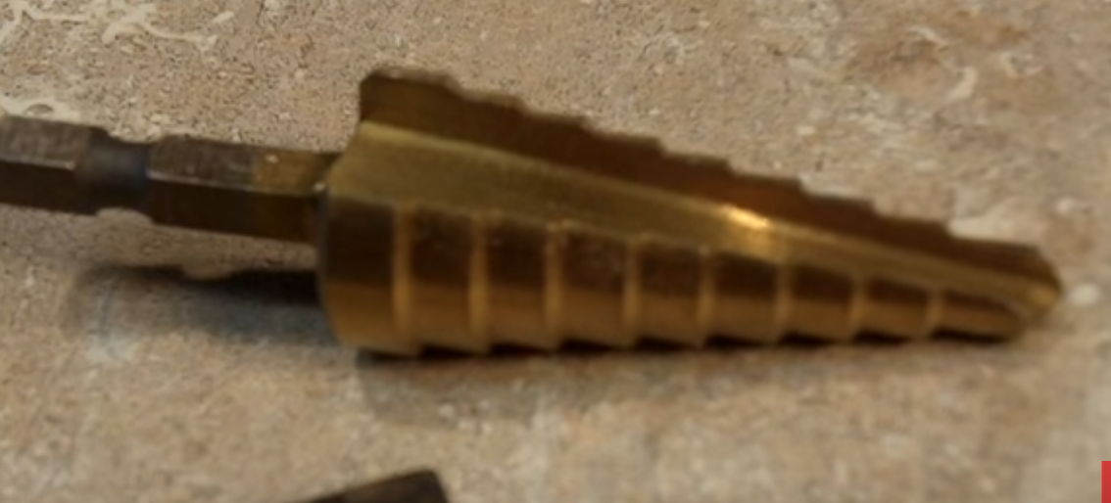
    - Masonry tips:
      * 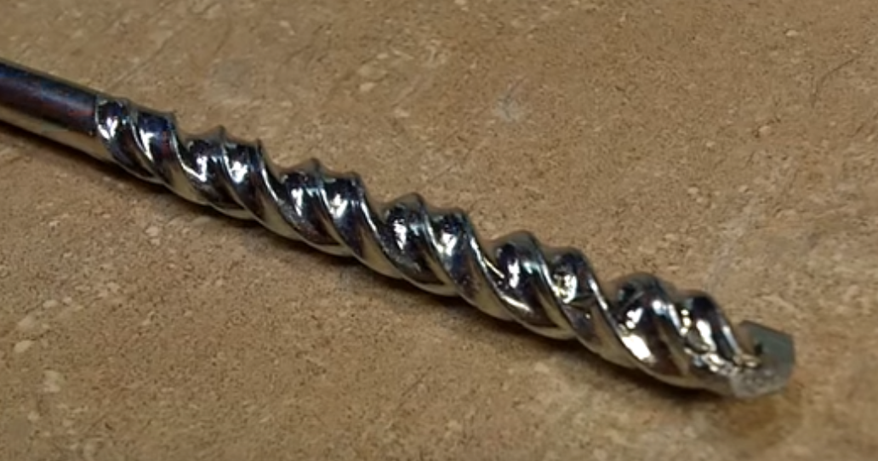
      * Note the carbide tip.
      * It is mostly used for boring into masonry stuff (brick, etc.)
        + You’ll get best results by pairing this bit w/ a rotary drill or hammer drill.
    - Countersink bit:
      * 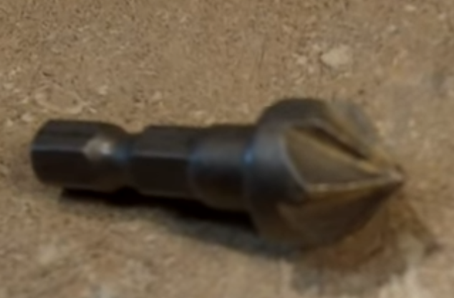
      * Used for **countersinking** **fasteners**. Esp. in wood.
    - Tile bit:
      * 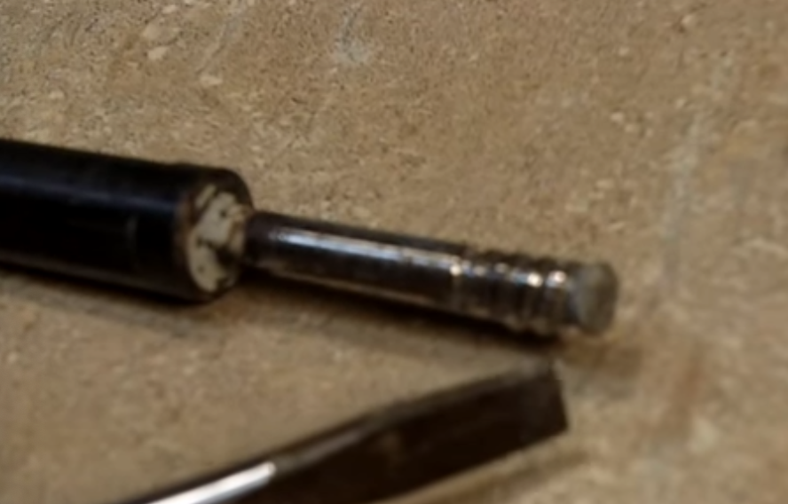
      * Bit is encrusted with diamond.
      * Good for stone (marble, granite, slate, etc.) and also **glass**
* How to use a speed square:
  + Why use a speed square?
    - Helps you determine angled cuts.
    - Can also act as a straight-edge when making cuts : )
  + Tutorial (e.g. Finding a 55 degree angle):
    - 1. Locate the **pivot point** on your sped square, as it is held in line with the straight edge of the wood
      * 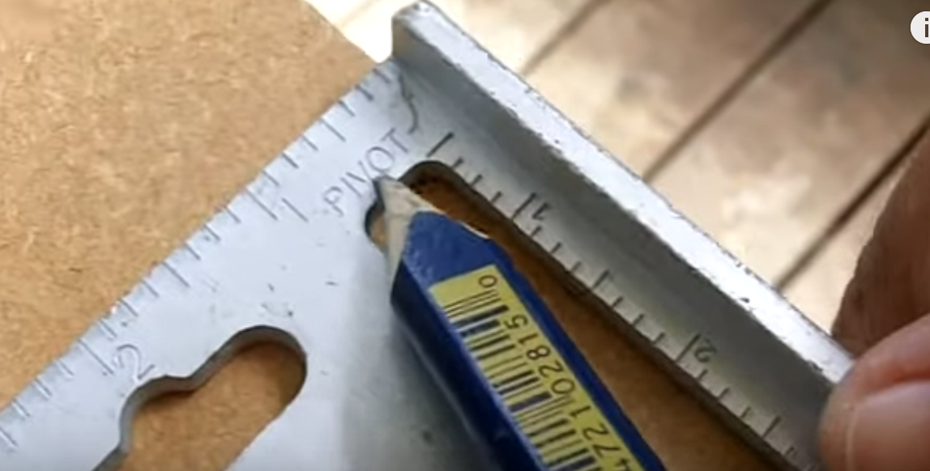
    - 2. As it is held in line with the straight edge of the wood, locate the “55” mark on the opposite side of the speed square:
      * 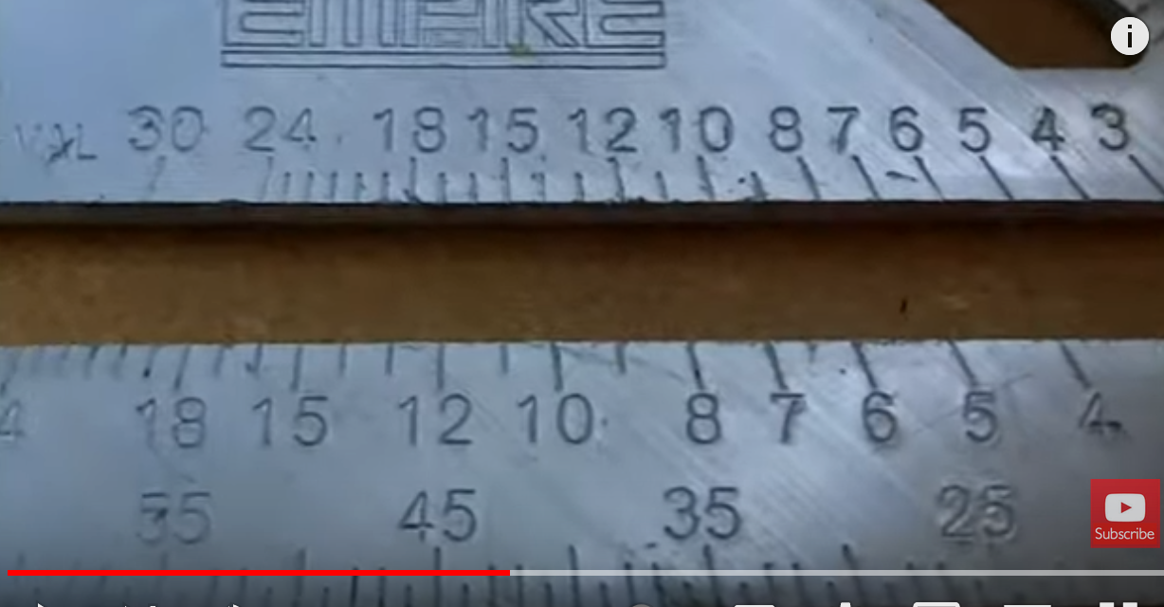
    - 3. Now, **pivot** the 55 degree mark so that it is in-line with the straight edge of the wood (where pivot point previously was)
      * 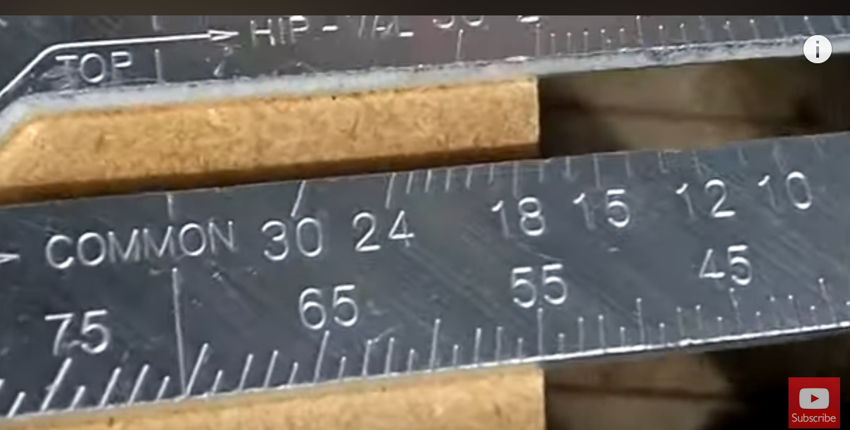
    - 4. Now, strike a line starting from the pivot point:
      * 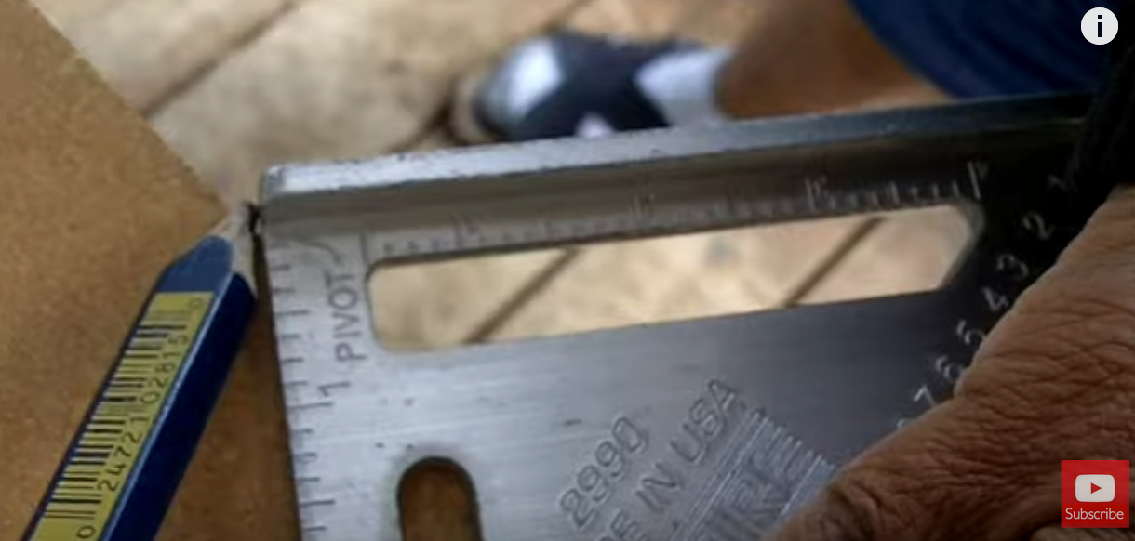
    - 5. Voila! That is your 55 degree angle : )
      * 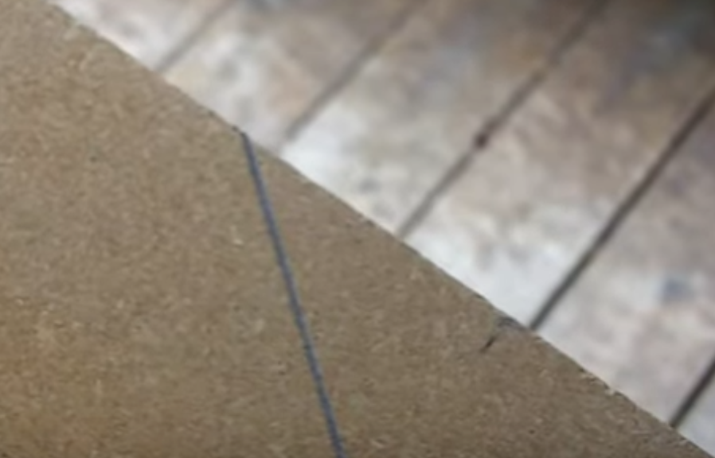
* How to mark center in a piece of wood without measuring
* To do this, we’re going to make a “centering jig”:
  + - * 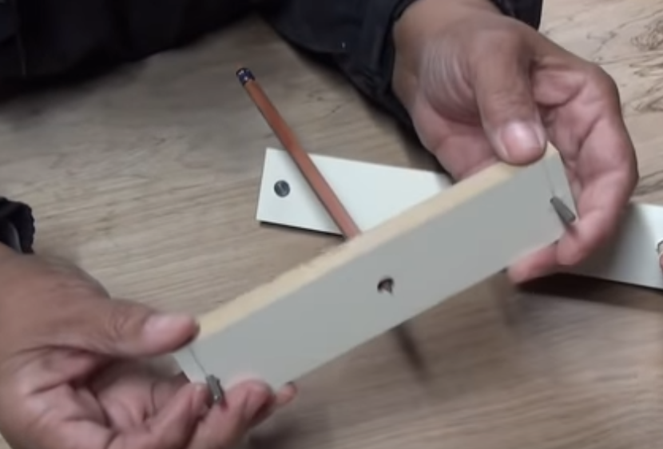
    - How to **make** the centering jig:
      * 1. On a small piece, mark two *pivoting pins* within equal distance to a centerpoint:
      * 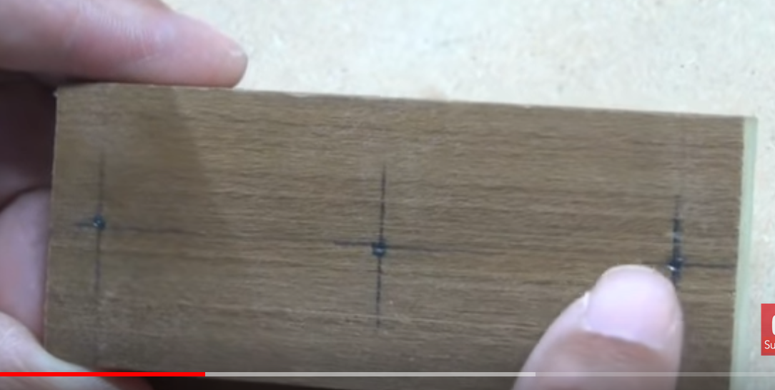
      * 2. Now drill through, appropriately countersinking the middle piece where the pencil will go:
      * 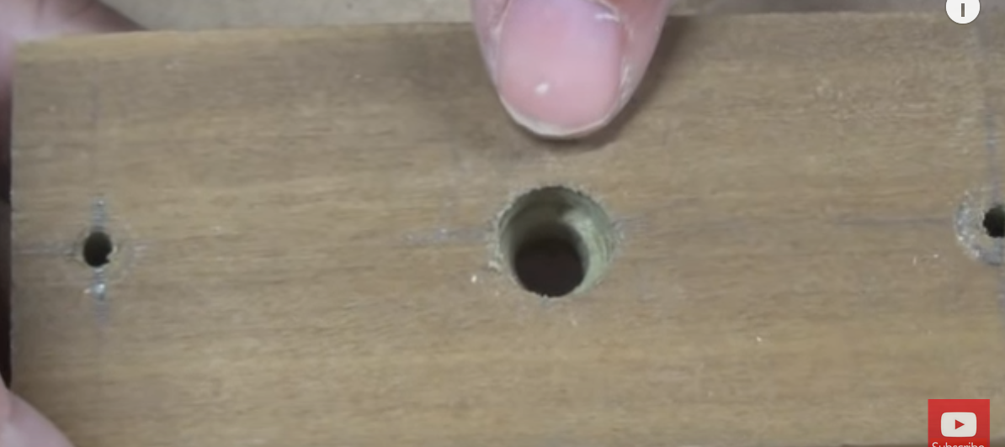
      * 3. Make the two pivoting pins by **cutting two framing nails (16d’s)** a half-inch beyond the thickness of your board
        + 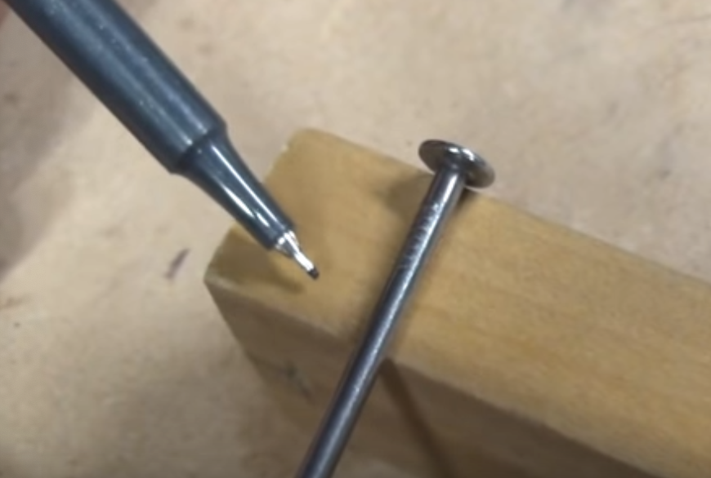
        + Cut the nail by placing it in a vise-grip and then taking a hacksaw to it:
        + 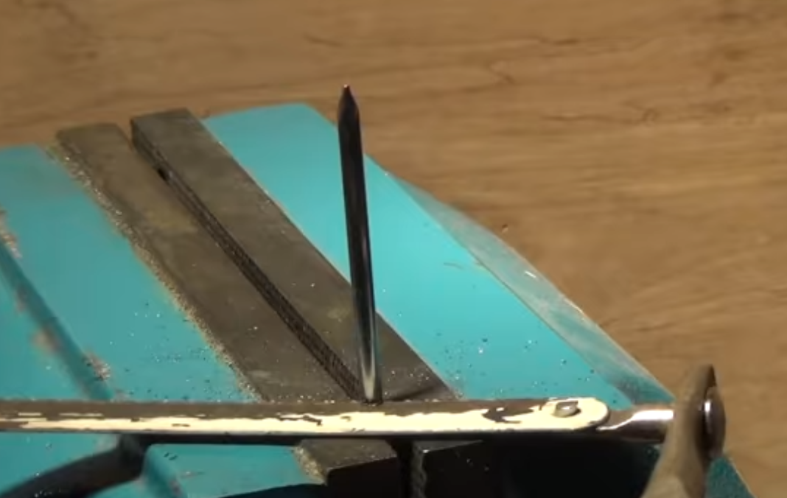
        + Be sure to *file the nail down!*
        + 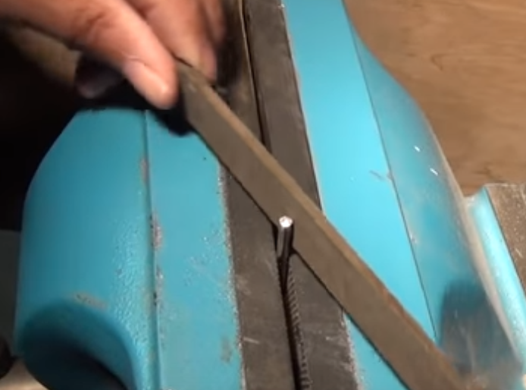
      * 4. Now tap the nails through, and the pencil too!
      * 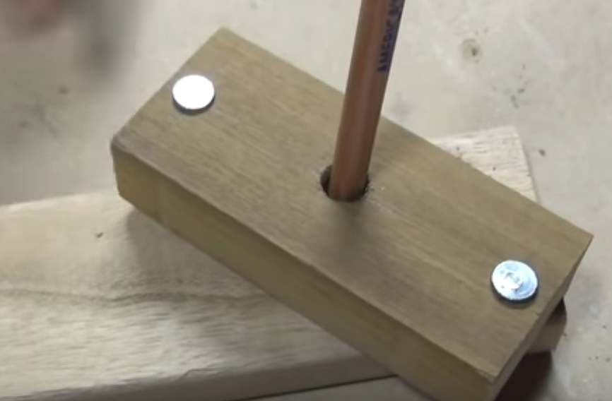
    - How to **use** the jig?
      * 1. Just put the jig over top of the board you’re trying to measure, **twist it** until it lies snug, and then run it down the length of the board:
      * 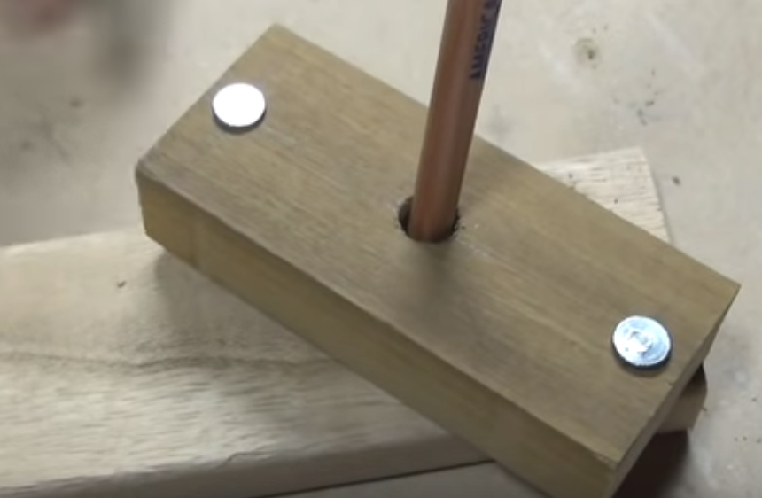
      * Note: You will likely want to make **several sizes** of this jig!
      * How to Make a Perfectly Straight Cut with a Circular (or Jig) Saw:
        + 1.Mark your width that you’re going to cut with a pencil.
        + 2. Take your circular saw and, from the outside of the blade to the outside of the **shoe**, measure it out:
        + 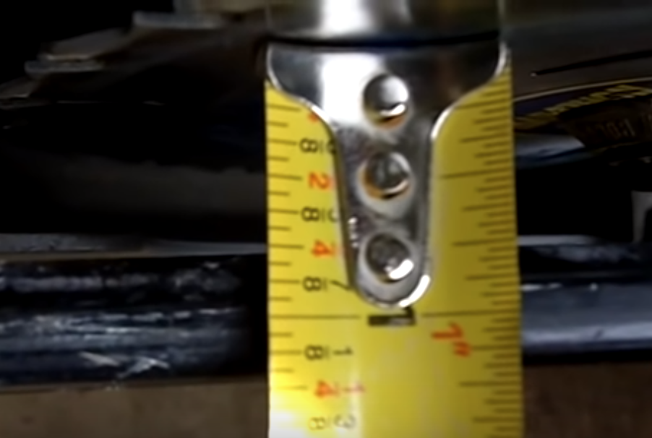
        + 3. Back on the board that you’re going to cut, measure that width from Step 2 and mark it **inwards** from the width in Step 1:
        + 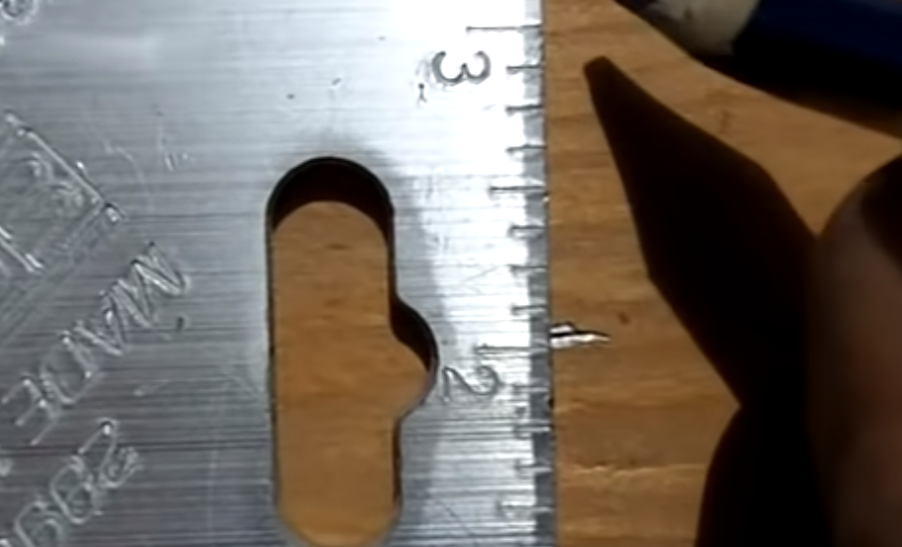
        + 4. Find a piece of scrap wood that has a perfectly straight edge. Requirements for this piece:

A. Longer or at least *as long as* the piece of wood you’re going to cut

B. It should have a perfectly straight edge

* + - * + 5. Clamp down the piece of guidewood at the width of Step 1 + Step 2 widths and run your saw. Voila!
        + 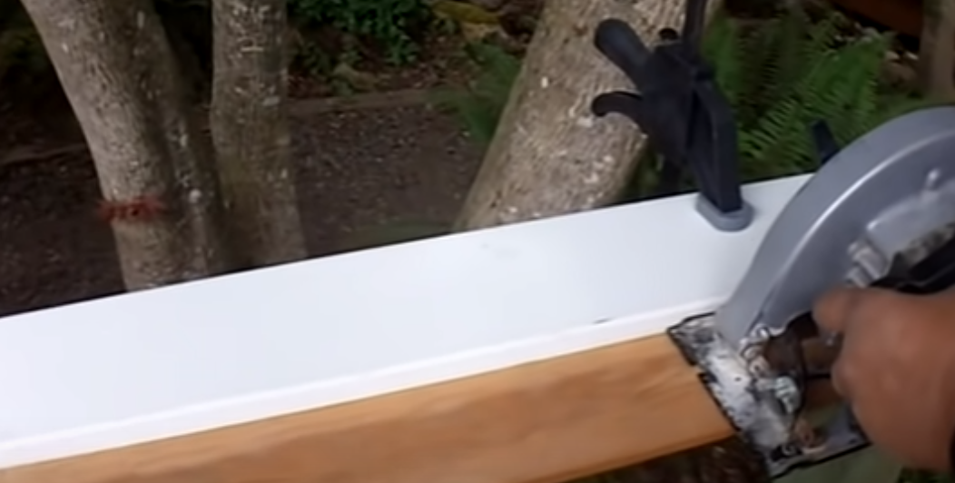
* How to Scribe, A Beginner’s Tutorial:
  + This tool is called a “winged divider”—it consists of a pencil and two legs
  + 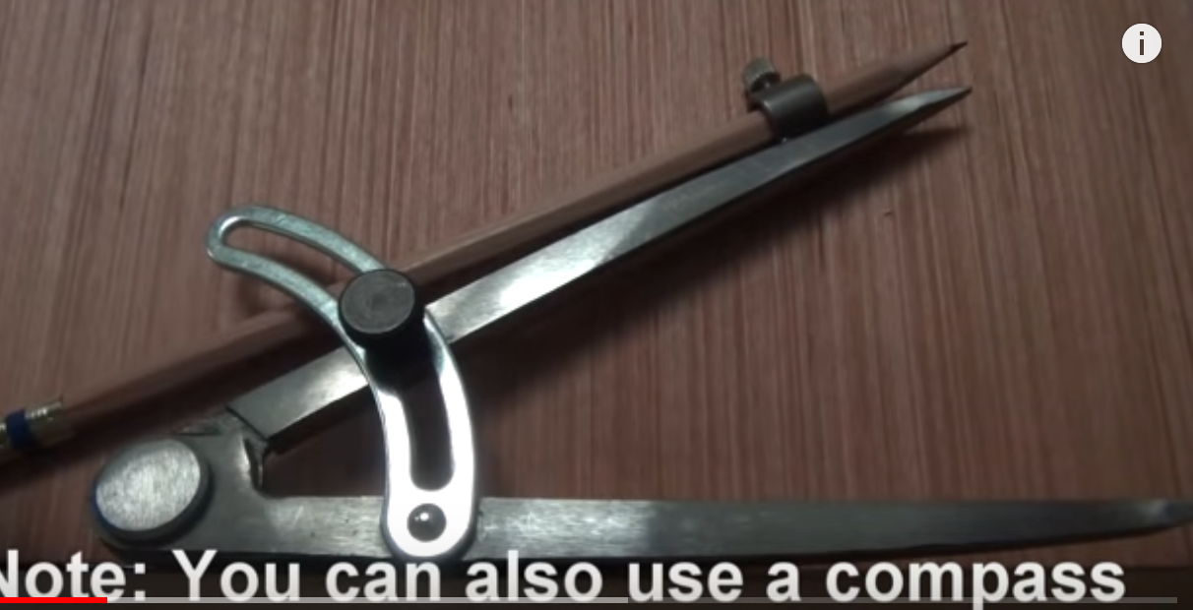
  + Scribing helps us to fit woodwork such as countertops, cabinets, etc. to uneven walls and other irregular surfaces like brick and stone
  + It’s pretty simple! Just set the non-pencil side against the surface of the irregular contour and trace it out on an adjacent piece of wood:
  + 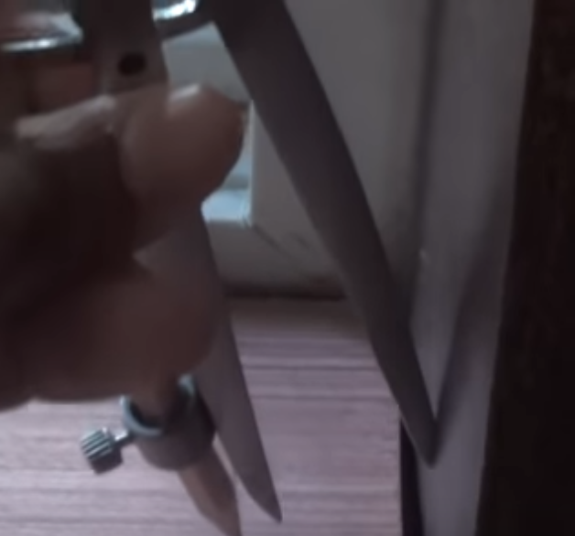
  + 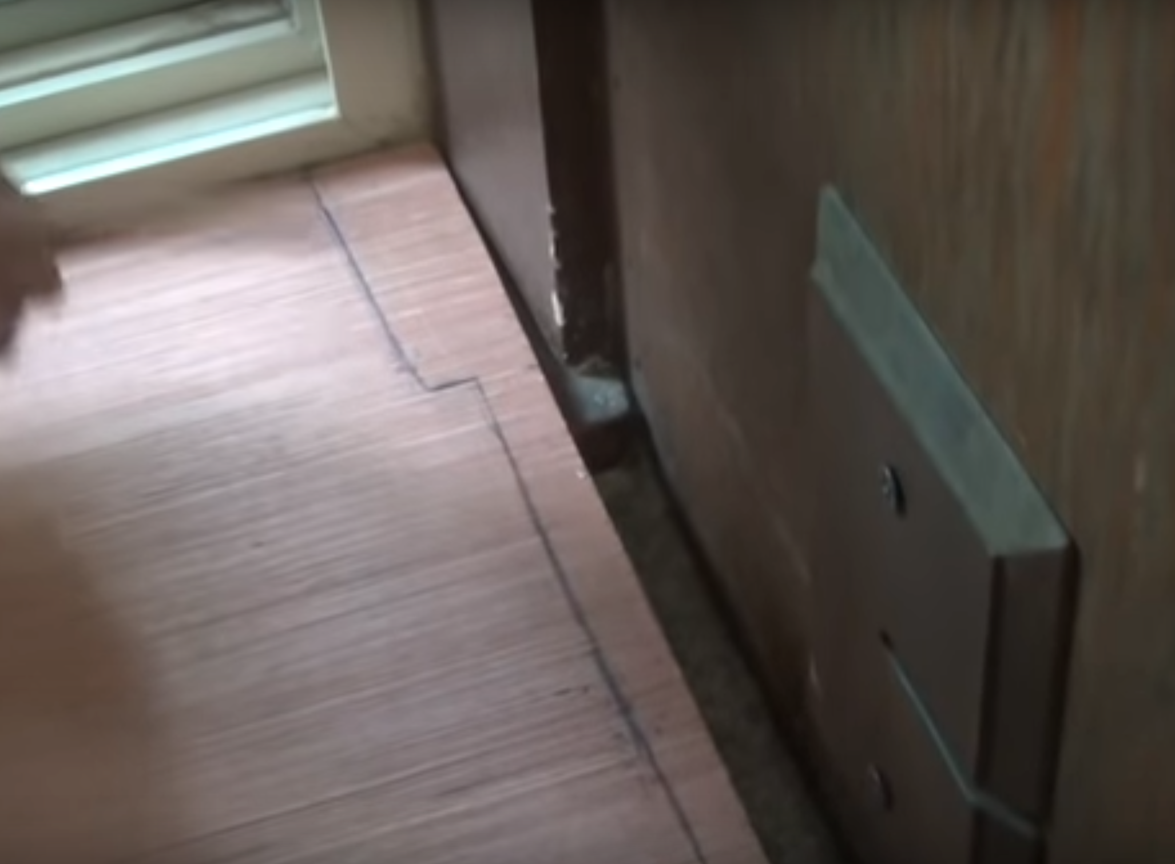
* Block Plane Basics:
  + Parts of a block plane:
    - Cap (can be loosened via screw)
      * 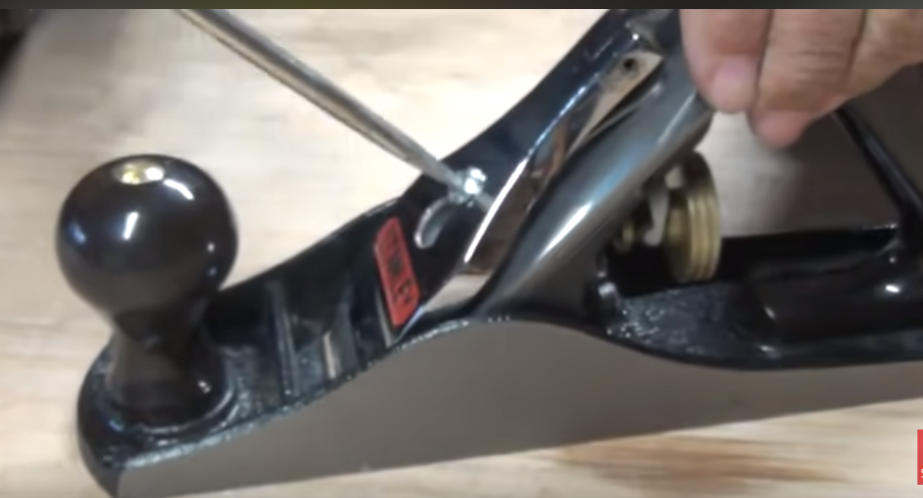
      * 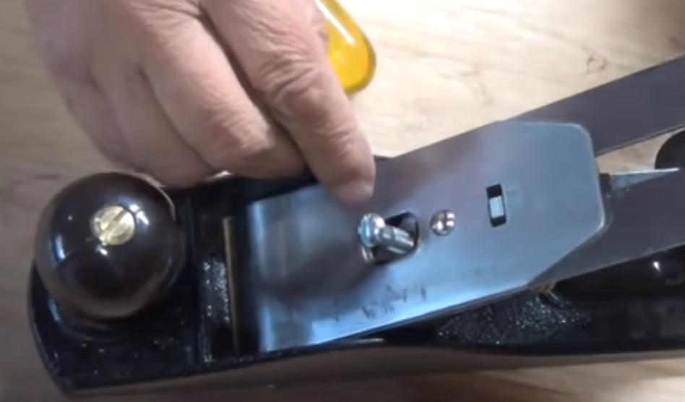
    - The part underneath all of this is called the “frog”
      * 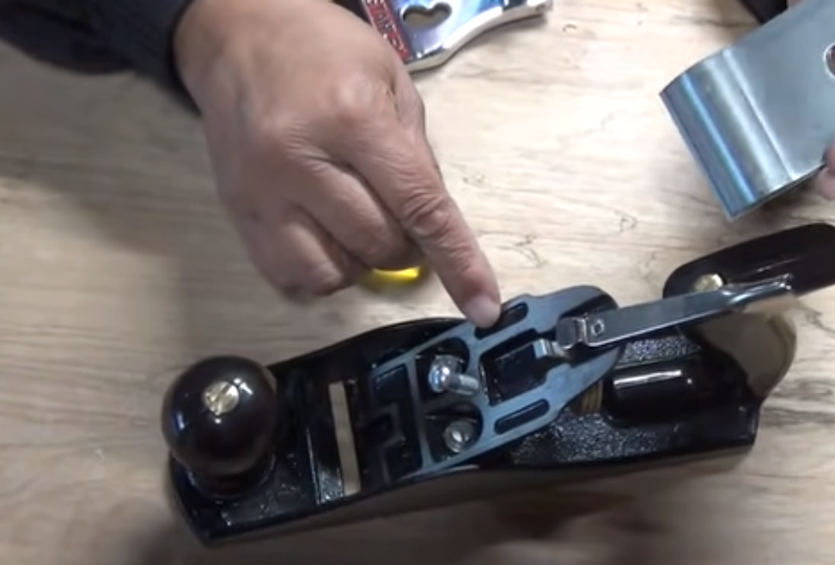
    - On back of the frog, there is typically a iknow that controls the depth of the blade:
      * 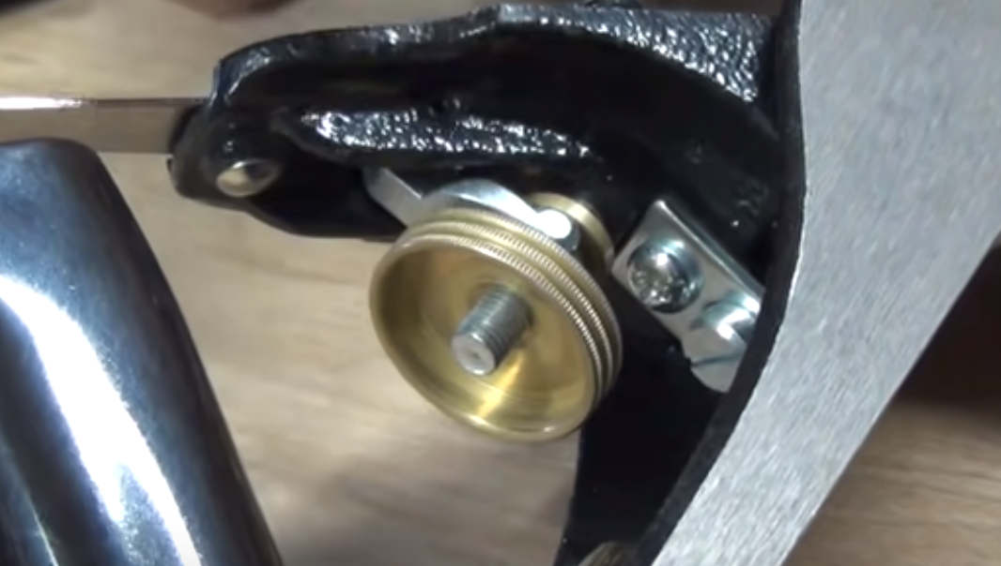
      * Note: These screws on either side can be used to adjust the frog, which in turn controls the width of the “mouth” which is open
* How to make a Plunge Cut with a Circular Saw (Cut Shape in Wood):
  + Let’s say that we wanna cut the following shape out of a board:
  + 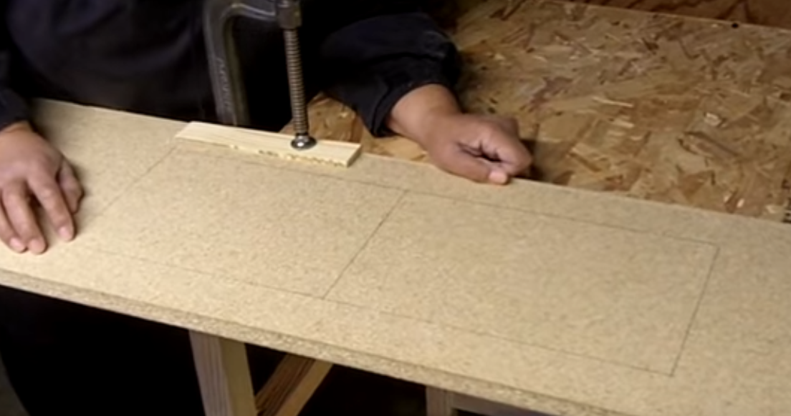
  + TBH, it’s pretty self explanatory. Just make sure to finish the job up with a handsaw, as you’re not going to want to **fully** cut everything out with the circular saw (too imprecise)